
HEALTH, SAFETY & ENVIRONMENT MANAGEMENT SYSTEM
DAN Construction Safety Manual (DCSM)
Materials Handling / Storage and Control of Substances Hazardous to Health (COSHH)

Document Control
Document No. | 01-000001-000000-DAN-HSE-PRC-000018 | Revision | R01
Issue Date | June 2026 | Classification | Controlled — Internal
Document Owner | HSE Department | Page Format | US Letter

Table of Contents

1. Purpose
2. Scope
3. References
4. Deliverable
5. General Materials Handling
6. General Materials Storage
7. Control of Substances Hazardous to Health (COSHH)
7.1 Risk Assessment Steps
7.2 Globally Harmonized System (GHS)
8. Hazardous Materials Storage
8.1 Explosives
9. Hazardous Materials Transportation
10. Records
11. Related Documents
Figures and Illustrations
Revision History

1. Purpose
This document describes the DAN requirements for the handling, transportation and storage of construction materials, and the methods for identifying and Controlling Substances Hazardous to Health (COSHH).
Note: For compressed-gas-cylinder handling and storage, see the Compressed Gas Cylinders chapter.

2. Scope
This document applies to all materials handling, storage and hazardous substances used by CONTRACTOR personnel on DAN project sites.

3. References
- 29 CFR 1926.152, .250, .252; NFPA 30 (flammable liquids), NFPA 70 (NEC), NFPA 80 (fire doors)
- DCSM — SH&E Risk Management
- DCSM — Hazard Communication
- EH40 Workplace Exposure Limit guidelines
- Globally Harmonized System (GHS) of Classification and Labelling

4. Deliverable
- COSHH Risk Assessment.

5. General Materials Handling
Where practical, manual material-handling tasks shall be avoided. Personnel shall be instructed in proper techniques before work, and shall seek assistance for tasks beyond their physical capability. Observe the following hierarchy when selecting a handling method:
- Eliminate the handling need by engineering;
- Move by mechanical device (lift truck, overhead crane, conveyor);
- Move by manual means with a handling aid (dolly or cart);
- Move using safe lifting techniques (see the Manual Handling chapter).
Provide proper tools, wear PPE, avoid high overhead lifts (stack to about waist height), and coordinate team lifts in unison. Use tag lines to control hoisted loads near personnel, and do not hoist unsecured bagged or loose materials by slings unless secured against falling.

6. General Materials Storage
- Handle and store materials in accordance with their MSDS, in a planned, orderly manner that does not endanger personnel or obstruct accessways, doorways, hoistways or exits.
- Do not store materials under overhead power lines; maintain clearance around fire doors (114 cm), and keep stored materials clear of hoistways, floor openings and exterior walls.
- Stack to facilitate safe handling; step back and cross-key bagged materials at least every 10 bags; remove nails from reusable lumber before stacking.
- Post and do not exceed maximum safe floor-load limits; observe pallet-rack weight limits; contain materials stored at or above 213 cm with shrink-wrap.
- Store with attention to fire characteristics: maintain at least 36 in. clearance to sprinkler heads; provide rated portable fire extinguishers within marked, accessible locations; separate incompatible materials by 25 ft or a 1-hour-rated barrier.

7. Control of Substances Hazardous to Health (COSHH)
A COSHH Risk Assessment shall be carried out where personnel may contact hazardous substances under normal or adverse conditions; its findings shall be included in the relevant AHA, and Safety Data Sheets shall be available at all locations where hazardous substances are used.

7.1 Risk Assessment Steps
- Assess the risks — identify the substance’s properties via its GHS classification, MSDS and packaging, and the exposure routes presented by the task;
- Decide the precautions — where preventing exposure is not reasonably practicable, control it using the MSDS, labelling, risk phrases and legal requirements;
- Monitor controls and exposure, and carry out health monitoring where the assessment or law requires it;
- Prepare plans for accidents, incidents and emergencies involving hazardous substances;
- Inform, train and supervise personnel, including the correct fitting and wearing of PPE.
Note: Examples of hazardous substances include silica dust (from concrete grinding, drilling, demolition), paints/sealants/silicones, fuels/oils/grease, biological agents (toilets, sewer pipes) and gases (confined spaces, sewer pipes).

7.2 Globally Harmonized System (GHS)
The GHS defines and classifies the hazards of chemical products and communicates information on labels and safety data sheets. GHS pictograms cover corrosive, toxic, gas under pressure, dangerous to the environment, flammable, explosive, oxidising, harmful/irritant and longer-term health hazards (e.g. carcinogenicity). Some labels may still display the older orange-square symbols.

8. Hazardous Materials Storage
- A qualified person designated by the Project Manager oversees all storage, handling and use of flammable and combustible liquids per NFPA 30; smoking is prohibited within 50 ft (15.2 m), with no-smoking signs posted.
- Use only approved containers — metal safety cans for flammable liquids over 1 gallon; label all containers per the Hazard Communication chapter.
- Store flammable/combustible liquids over 25 gallons in an approved cabinet labelled “FLAMMABLE — KEEP FIRE AWAY”; do not exceed 60 gal flammable / 120 gal combustible per cabinet, nor more than three cabinets per storage area.
- Stack combustible materials securely (max 16 ft high) and keep them at least 10 ft from any building; outdoor flammable-liquid stacks ≤ 60 gal/container and ≤ 1,100 gal/area, separated by 5 ft and 20 ft from any structure, with a 12-ft access way within 200 ft.
- Grade storage areas to divert spills, or surround with a curb/dike ≥ 12 in. high; bond and ground containers to prevent static; provide ventilation to prevent vapour accumulation.
- If clothing becomes contaminated with flammable/combustible material, STOP WORK IMMEDIATELY and remove or wet down the clothing.

8.1 Explosives
- Use explosives per the Blasting chapter and applicable KSA and Civil Defence requirements; no smoking, open lights or fire within 50 ft of any area where explosives are handled.
- Open containers using non-sparking tools, remove explosives only as needed for immediate use, and keep them separated from detonators in their original containers.

9. Hazardous Materials Transportation
Transportation shall be carried out by authorised personnel in accordance with KSA and Civil Defence requirements; only the authorised driver and a properly trained helper may ride in vehicles carrying explosive materials or detonators. Hazardous materials shall be disposed of per the Waste Management chapter.

10. Records
COSHH risk assessments, Safety Data Sheets, and storage and transport records shall be maintained on-site and made available to DAN on request.

11. Related Documents
- DCSM — Hazard Communication
- DCSM — Fire Protection and Prevention
- DCSM — SH&E Risk Management
- COSHH Risk Assessment Template

Figures and Illustrations
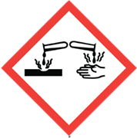
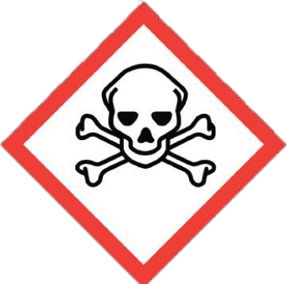
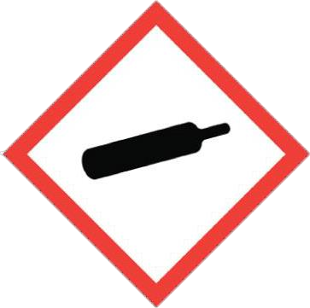
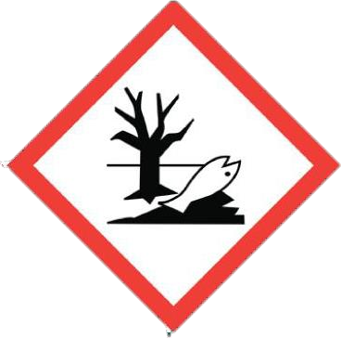
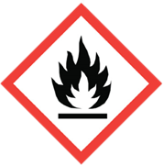
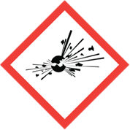
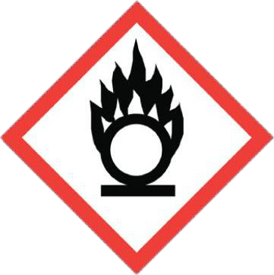
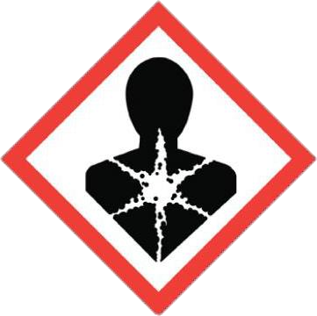
Figure 18-1 GHS Safety Labels

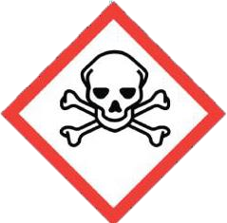
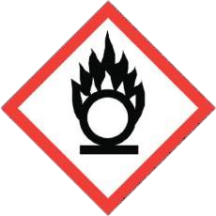
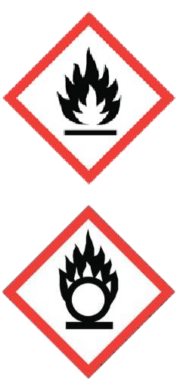
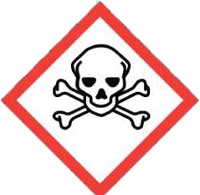



Revision History
Rev. | Date | Description of Change | Approved By
R00 | June 2026 | Initial issue. Restructured to the DAN integrated HSSE management-system template and re-branded in accordance with the DAN Brand Book. | Project Director
R01 | June 2026 | Re-coded to the updated DAN document-numbering convention (01-000001-000000-DAN-{discipline}-{type}-{seq}). | Project Director

